SCREENSHOTS FOR MACHINE PROBLEM 1(MATLAB)

**SCRIPT:**

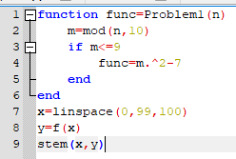

**OUTPUT:**

**\*The graph is from Octave**

